Task 13 :S3 Lifecycle Management Assignment

1. Create an S3 Bucket named "my-zomato-images" and Upload 3 Images
Ans: 1. Sign in to the AWS Management Console.
2. Open Amazon S3.
3. Click Create Bucket.
4. Enter bucket name: my-zomato-images (or a unique variation if unavailable).
5. Select your preferred AWS Region (e.g., Asia Pacific – Mumbai).
6. Leave other settings as default and click Create Bucket.
7. Open the bucket, click Upload, and upload at least three images such as pizza.jpg, burger.jpg, and pasta.jpg.
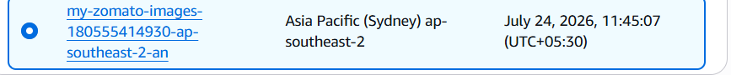
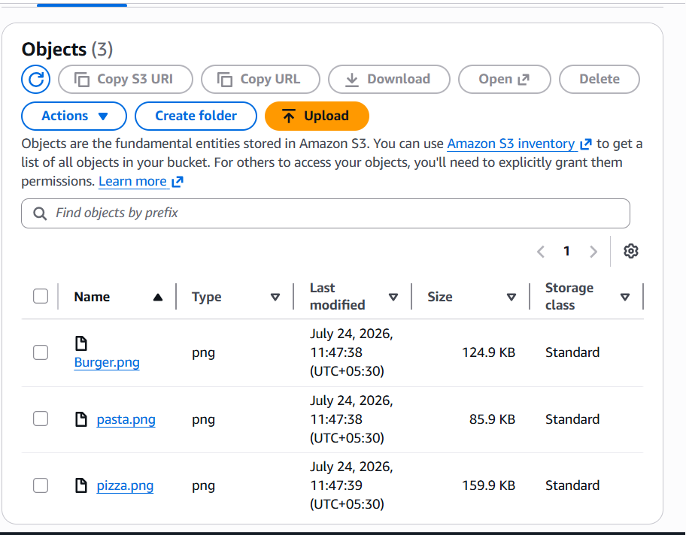

2. Configure a Lifecycle Rule to Move Files to Glacier after 30 Days
Ans: 1. Open the bucket and go to the Management tab.
2. Click Create Lifecycle Rule.
3. Rule Name: MoveToGlacier30Days.
4. Apply the rule to all objects.
5. Choose Transition current versions of objects.
6. Set transition after 30 days to Glacier Flexible Retrieval.
7. Create the rule.
Result: Objects older than 30 days automatically transition to Glacier.
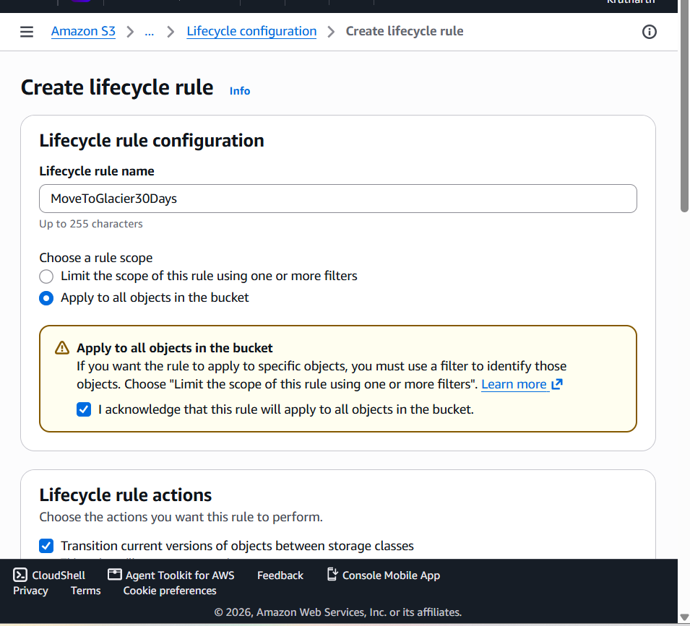
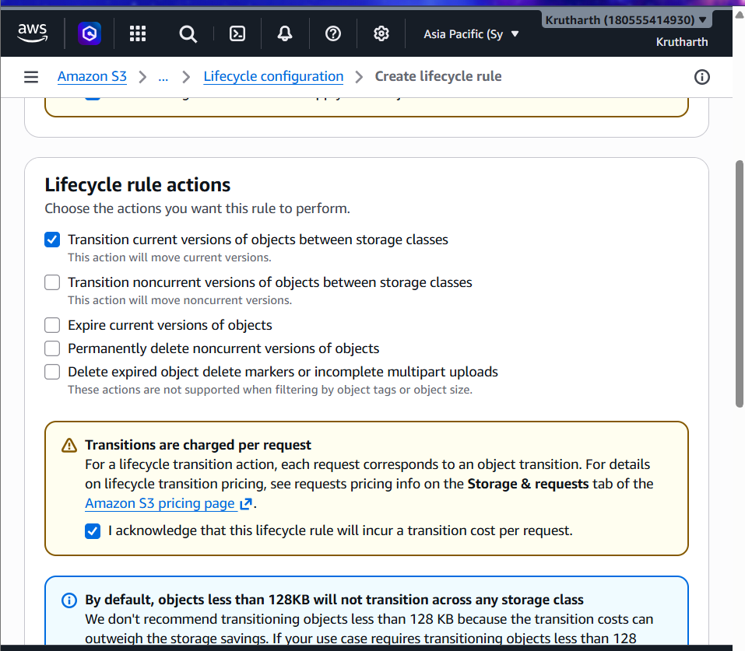
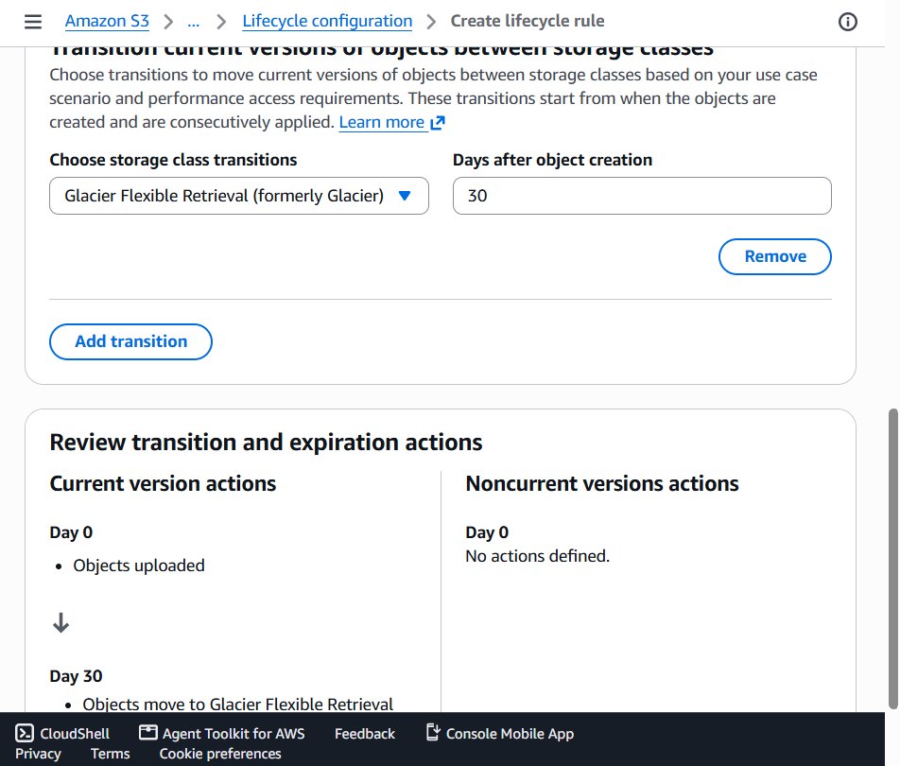
3. Cost Comparison (5 GB)
Storage Class | Price/GB/Month | 5 GB Cost | Approx.
S3 Standard | ₹2.05 | ₹10.25
S3 Glacier Flexible Retrieval | ₹0.33 | ₹1.65
Estimated monthly savings: ₹8.60 (approx.).

4. Lifecycle Rule to Delete 'offers/' Objects after 60 Days
Ans: 1. Go to Management > Create Lifecycle Rule.
2. Rule Name: DeleteOffersAfter60Days.
3. Limit scope using prefix: offers/.
4. Select Expire current versions of objects.
5. Set deletion after 60 days and save.

5. Sample Lifecycle Policy JSON
Ans: {
"Rules": [
{
"ID": "TransitionAndDeleteRule",
"Status": "Enabled",
"Filter": {"Prefix": ""},
"Transitions": [
{"Days": 15, "StorageClass": "GLACIER"}
],
"Expiration": {"Days": 180}
}
]
}

JSON Explanation
Section | Explanation
Rules | Contains lifecycle rules.
ID | Unique rule identifier.
Status | Enables the rule.
Filter | Applies to all objects.
Transitions | Moves objects after 15 days.
StorageClass | GLACIER storage class.
Expiration | Deletes objects after 180 days.

